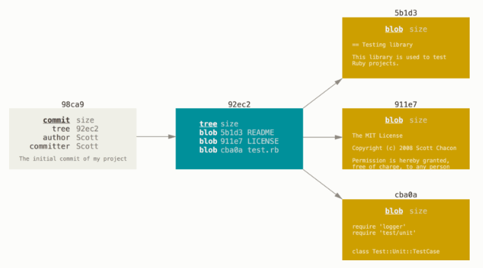

**Commit Object**: holds:  
author, message, pointer to tree object

**Tree Object**: holds:  
pointer to blobs, file names, (other trees?)

**Blob Object**: holds:  
file content

Commit objects point back to their parent commit and to a tree object.

…Merge commit objects…

**Branch object**: points to a commit. Creating a new branch just creates a pointer to the commit you’re currently on (creating v1.0 on the left).  
TECHNICAL: 40 byte SHA-1 checksum of the commit it points to, plus 1 newline byte. The checksums are stored in:  
.git/refs/heads/<file named as the branch name>

**HEAD**: points to a branch object. Whichever branch the HEAD points to will be what’s in the working directory.

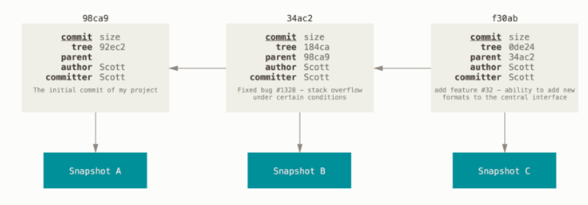

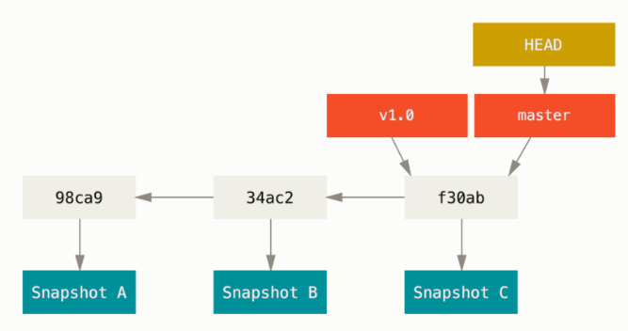

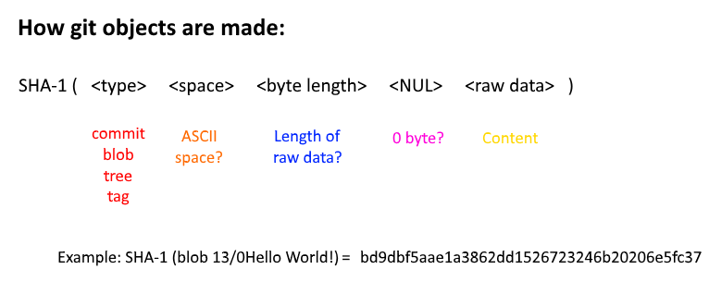

$ git fetch origin

Running “git fetch origin” will download the remote’s new history as shown below:

